Experiment No-04
Design of a 4-bit Full Adder using Verilog
1.1 Objectives
The main objectives of this experiment are summarized as:
- To design and simulate a half adder using Verilog dataflow modeling.
- To design and simulate a 1-bit full adder and verify it against the standard full-adder truth table.
- To extend the full adder design to 4-bit, 8-bit, 16-bit, 32-bit and 64-bit widths and verify ripple-carry addition at each width.
- To design and verify a 4-bit subtractor and a 4-bit multiplier using the same dataflow modeling and compile-elaborate-simulate flow.
Keywords- Half adder, full adder, ripple-carry addition, dataflow modeling, Verilog HDL, Cadence Incisive Enterprise Simulator (IES), NCLaunch, SimVision, test bench, waveform verification.
1.2 Theory
1.2.1 Half Adders and Full Adders
A half adder is a combinational circuit that adds two one-bit binary numbers, a and b, and produces a sum bit and a carry bit, given by sum = a ⊕ b and carry = a · b. A half adder cannot accept an incoming carry, so it cannot by itself be chained to add multi-bit numbers. A full adder extends this by adding three one-bit numbers two operand bits, a and b, and an incoming carry, cin and producing a sum bit and an outgoing carry bit, cout; a full adder can be built from two half adders and an OR gate, since sum = a ⊕ b ⊕ cin and cout = (a · b) + cin · (a ⊕ b). The truth tables of the half adder and the full adder are shown in Table-1.1 and Table-1.2.

a | b | sum | carry
0 | 0 | 0 | 0
0 | 1 | 1 | 0
1 | 0 | 1 | 0
1 | 1 | 0 | 1
Table-1.1. Truth table of a half adder with inputs a, b and outputs sum, carry.

a | b | cin | sum | carry
0 | 0 | 0 | 0 | 0
0 | 0 | 1 | 1 | 0
0 | 1 | 0 | 1 | 0
0 | 1 | 1 | 0 | 1
1 | 0 | 0 | 1 | 0
1 | 0 | 1 | 0 | 1
1 | 1 | 0 | 0 | 1
1 | 1 | 1 | 1 | 1
Table-1.2. Truth table of a full adder with inputs a, b, cin and outputs sum, carry.
1.2.2 Ripple-Carry Multi-Bit Addition
An n-bit adder can be built by chaining together n 1-bit full adders, with the carry-out of each stage connected to the carry-in of the next and the carry-in of the least significant stage tied to the overall carry-in; this arrangement is known as a ripple-carry adder, since the carry must propagate (“ripple”) through every stage before the most significant sum bit is valid. The Verilog language also allows an n-bit addition to be described behaviorally with the built-in + operator applied directly to n-bit input vectors, for example assign {cout, sum} = a + b + cin, letting the simulator (or, for synthesis, the target technology library) resolve the underlying bit-by-bit carry propagation rather than the designer wiring it explicitly. In this experiment, both styles are discussed: Section 1.5 compares the hierarchical, generate-block-based construction described in the lab manual with the vector-based dataflow style that was actually used to implement the 4-bit, 8-bit, 16-bit, 32-bit and 64-bit adders.
1.2.3 Cadence Incisive Enterprise Simulator (IES) and the NCLaunch Design Flow
As in the previous experiment, the Cadence Incisive Enterprise Simulator (IES), invoked through the NCLaunch graphical front end, was used to compile, elaborate, and simulate each design. For every one of the nine designs in this experiment, a lab/simulation directory was created, a cds.lib file mapping a worklib work library was created (selecting the “Don’t include any libraries (Verilog design)” option), the design and test bench source files were compiled with ncvlog, the test bench was elaborated with ncelab as the top-level module, and the resulting worklib snapshot was simulated, opening the Design Browser, Console, and Waveform windows of SimVision to inspect the $monitor output and the signal timing diagrams.
1.3 Hardware/Software Used for the Experiment
1. Cadence Incisive Enterprise Simulator (IES), invoked through NCLaunch
2. ncvlog (Verilog compiler), ncelab (elaborator), and the Incisive simulator (ncsim)
3. SimVision waveform viewer (Design Browser, Console, and Waveform windows)
4. gedit text editor, used to write the Verilog source and test bench files
5. Verilog HDL (IEEE 1364), with a simulation timescale of 1 ns / 1 ps
6. Linux workstation running the Cadence design environment

1.4 Experimental and Simulation Analysis
Nine designs a half adder, a 1-bit full adder, 4-bit/8-bit/16-bit/32-bit/64-bit full adders, a 4-bit subtractor, and a 4-bit multiplier were each written in gedit, compiled and elaborated in NCLaunch, and simulated in SimVision, following the same compile (ncvlog) – elaborate (ncelab) – simulate flow described in Experiment 3. The Verilog source code, test bench, NCLaunch compilation window, and SimVision console and waveform results for each design are presented in the following subsections.
1.4.1 Half Adder (half_adder)
The half adder was described using two dataflow (continuous assignment) statements on scalar inputs a and b: sum = a ^ b and carry = a & b. The Verilog source code is shown in Figure-1.1.
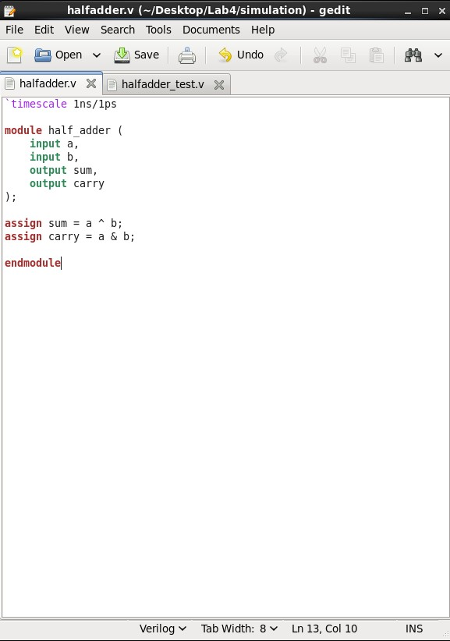 | 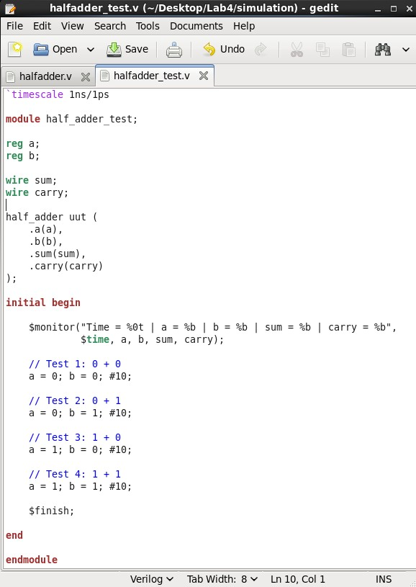
Figure-1.1. Verilog source code (halfadder.v) for the half adder: two continuous-assignment statements, sum = a ^ b and carry = a & b, describing a dataflow half adder with scalar inputs a, b. | Figure-1.2. Verilog test bench source code (halfadder_test.v), instantiating half_adder as uut and applying all four combinations of a and b (Test 1 to Test 4), each held for 10 ns.

A self-checking test bench (halfadder_test.v) applied all four combinations of a and b, each held for 10 ns, while a $monitor statement printed a, b, sum and carry on every change. The test bench source code is shown in Figure-1.2.

The design compiled and elaborated without errors, with the worklib populated with the half_adder and half_adder_test modules and a Snapshots entry for worklib.half_adder_test:module, as shown in Figure-1.3.

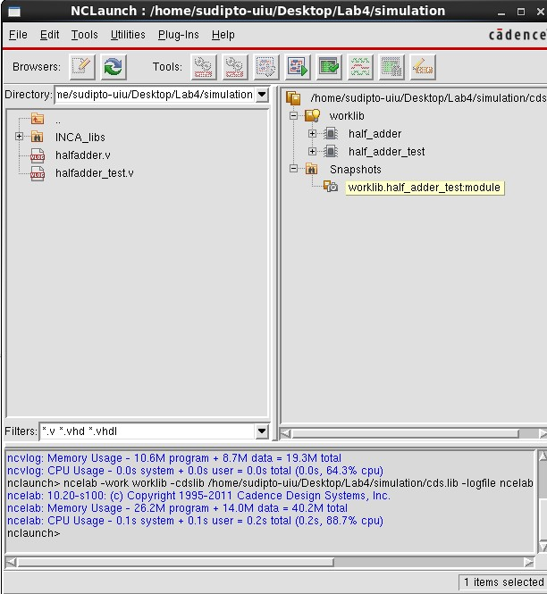 | 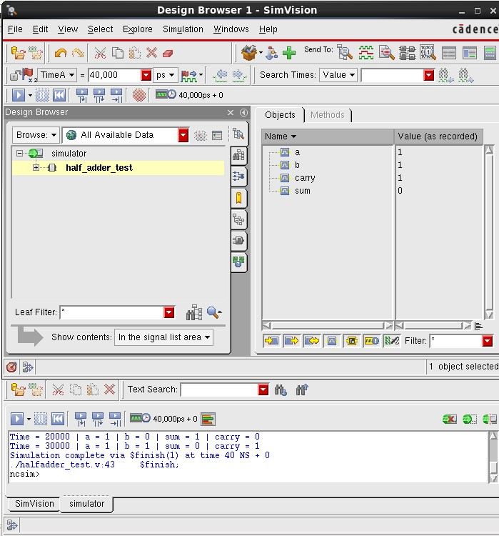
Figure-1.3. NCLaunch window for the half adder, showing the worklib with the compiled half_adder and half_adder_test modules and the elaborated Snapshots entry, confirming successful compilation and elaboration. | Figure-1.4. SimVision Design Browser and Console windows for half_adder_test, showing the recorded signal values and the $monitor output confirming correct half adder behaviour, with the simulation completing via $finish at 40 ns.
The SimVision Console output confirms correct operation for example, at Time = 20,000 ps, a = 1 and b = 0 give sum = 1 and carry = 0, and at Time = 30,000 ps, a = 1 and b = 1 give sum = 0 and carry = 1 with the simulation completing via $finish at 40 ns, as shown in Figure-1.4. The corresponding waveform, plotting a, b, carry and sum over the full 40 ns simulation, is shown in Figure-1.5.
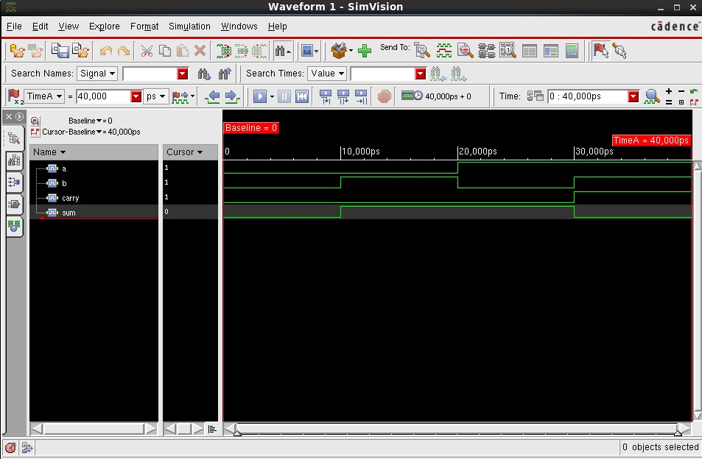
Figure-1.5. SimVision waveform for half_adder_test, showing a, b, carry and sum over the full 40 ns simulation, confirming correct half adder behaviour for all four input combinations.
1.4.2 1-bit Full Adder (full_adder)
Rather than instantiating two half_adder modules and an OR gate as suggested in the lab manual, the 1-bit full adder was described directly as two dataflow statements on scalar inputs a, b and cin: sum = a ^ b ^ cin and carry = (a & b) | (b & cin) | (cin & a). The Verilog source code is shown in Figure-1.6.

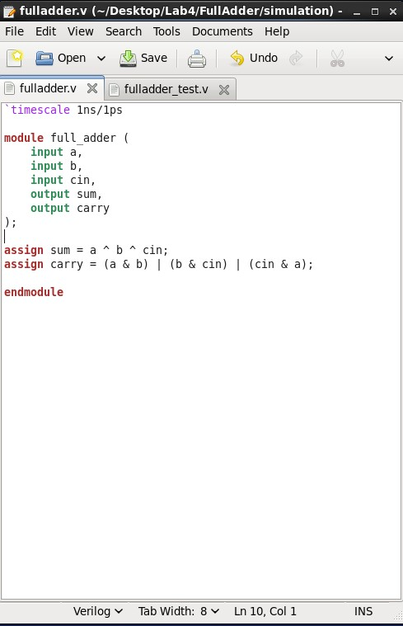 | 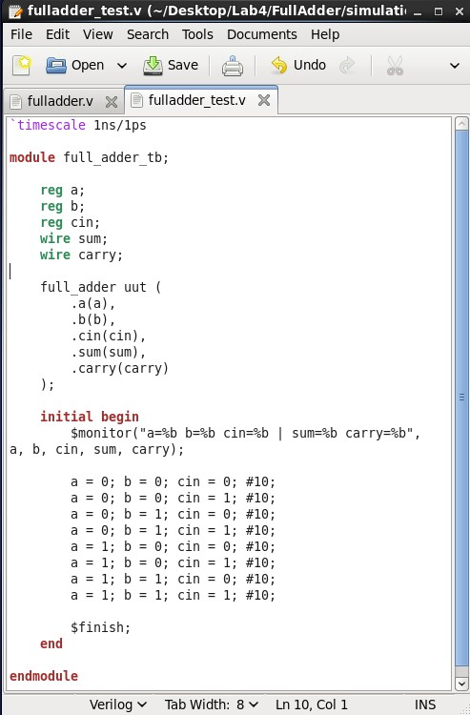
Figure-1.6. Verilog source code (fulladder.v) for the 1-bit full adder: a direct dataflow description, sum = a ^ b ^ cin and carry = (a & b) | (b & cin) | (cin & a), rather than a structural composition of half-adder instances. | Figure-1.7. Verilog test bench source code (fulladder_test.v), instantiating full_adder as uut and applying all eight combinations of a, b and cin, each held for 10 ns.

The test bench (fulladder_test.v) applied all eight combinations of a, b and cin, each held for 10 ns, while a $monitor statement printed every signal on each change. The test bench source code is shown in Figure-1.7.

The design compiled and elaborated without errors, with the worklib populated with the full_adder and full_adder_tb modules and a Snapshots entry for worklib.full_adder_tb:module, as shown in Figure-1.8.

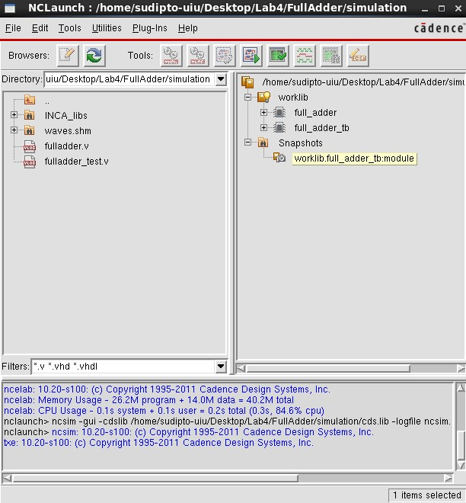 | 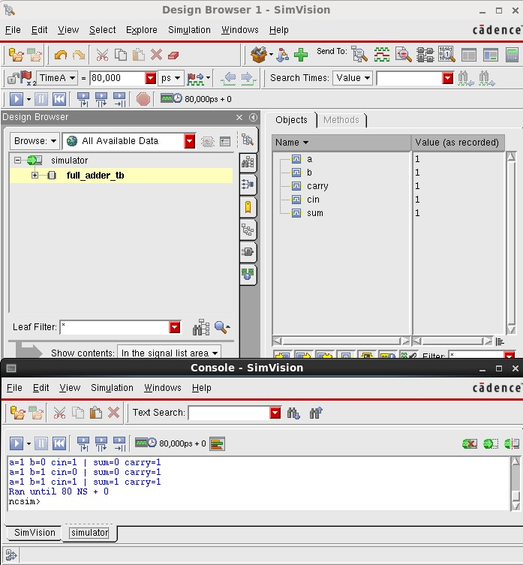
Figure-1.8. NCLaunch window for the 1-bit full adder, showing the worklib with the compiled full_adder and full_adder_tb modules and the elaborated Snapshots entry, confirming successful compilation and elaboration. | Figure-1.9. SimVision Design Browser and Console windows for full_adder_tb, showing the recorded signal values and $monitor output confirming correct 1-bit full adder behaviour, with the simulation completing via $finish at 80 ns.
The SimVision Console output confirms correct operation across all eight input combinations for example, a = 1, b = 0, cin = 1 gives sum = 0 and carry = 1 (1 + 0 + 1 = 2), and a = 1, b = 1, cin = 1 gives sum = 1 and carry = 1 (1 + 1 + 1 = 3) with the simulation completing via $finish at 80 ns, as shown in Figure-1.9. The corresponding waveform, plotting a, b, cin, sum and carry over the full 80 ns simulation, is shown in Figure-1.10.

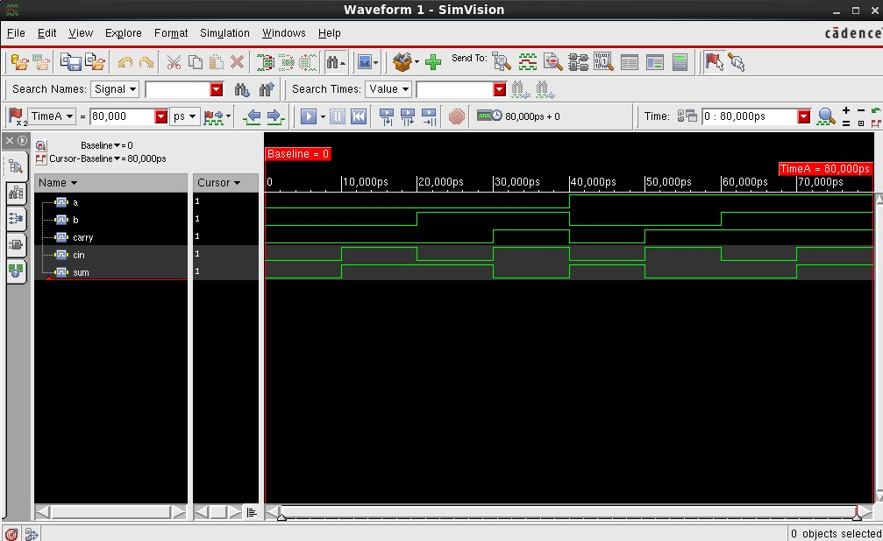 | Figure-1.10. SimVision waveform for full_adder_tb, showing a, b, cin, sum and carry over the full 80 ns simulation, confirming correct 1-bit full adder behaviour for all eight input combinations.
1.4.3 4-bit Full Adder (fulladder4)
The 4-bit full adder was described using vector notation, with 4-bit input vectors a[3:0] and b[3:0], a scalar carry-in cin, and a single behavioral/dataflow statement, assign {carry, sum} = a + b + cin, using Verilog’s built-in addition operator on the concatenated {carry, sum} result rather than a generate block instantiating four 1-bit full adders. The Verilog source code is shown in Figure-1.11.

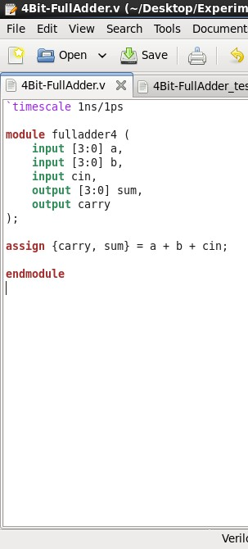 | 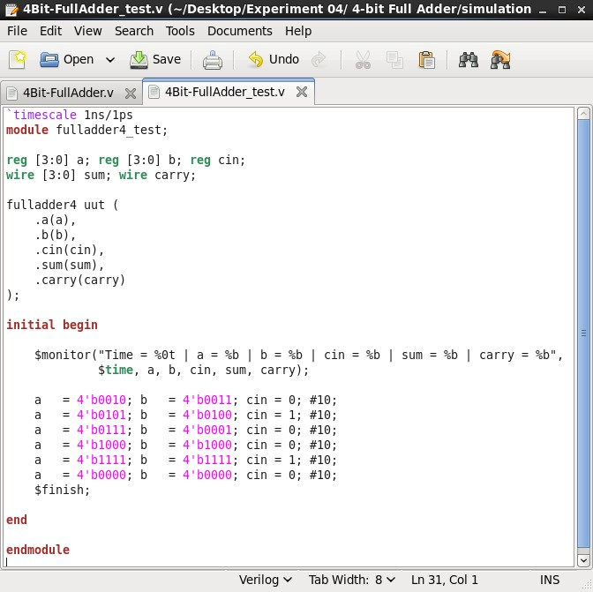
Figure-1.11. Verilog source code (4Bit-FullAdder.v) for the 4-bit full adder: a vector-based dataflow description, assign {carry, sum} = a + b + cin, with 4-bit inputs a[3:0], b[3:0] and a scalar cin. | Figure-1.12. Verilog test bench source code (4Bit-FullAdder_test.v), instantiating fulladder4 as uut and applying six 10 ns-wide 4-bit stimulus vectors, including a = b = 4’b1111, cin = 1.

The test bench (4Bit-FullAdder_test.v) applied six 4-bit stimulus vectors (10 ns each), including a = b = 4’b1111 with cin = 1, exercising the carry-out path, while a $monitor statement printed every signal on each change. The test bench source code is shown in Figure-1.12.

The design compiled and elaborated without errors, with the worklib populated with the fulladder4 and fulladder4_test modules and a Snapshots entry for worklib.fulladder4_test:module, as shown in Figure-1.13.

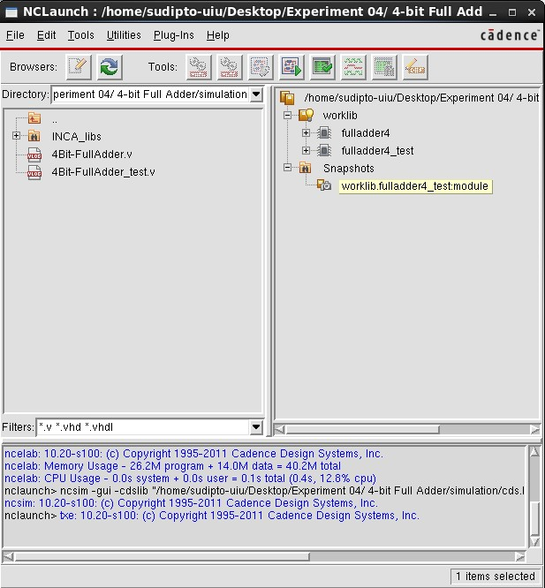 | 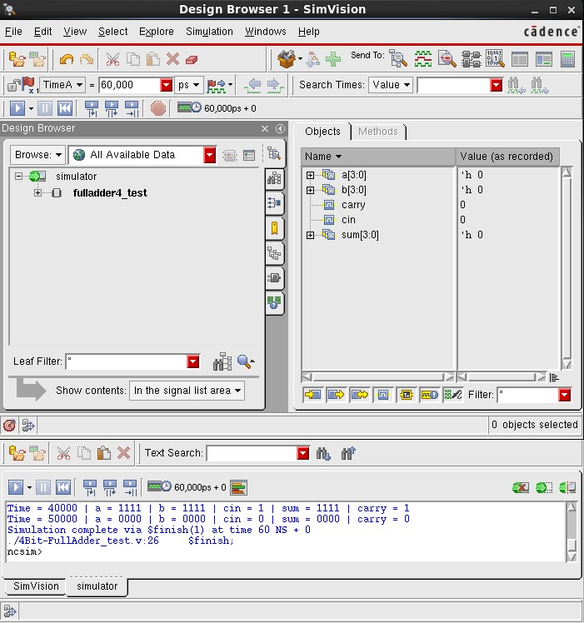
Figure-1.13. NCLaunch window for the 4-bit full adder, showing the worklib with the compiled fulladder4 and fulladder4_test modules and the elaborated Snapshots entry, confirming successful compilation and elaboration. | Figure-1.14. SimVision Design Browser and Console windows for fulladder4_test, showing the recorded signal values and $monitor output confirming that sum and carry correctly equal a + b + cin for each applied vector.
The applied vectors match the arithmetic result of a + b + cin in every case; for example, a = 4’b1111 (15), b = 4’b1111 (15) and cin = 1 give 15 + 15 + 1 = 31, i.e. sum = 4’b1111 and carry = 1, as confirmed by the SimVision Console output in Figure-1.14. The corresponding waveform, plotting a, b, cin, sum and carry over the full 60 ns simulation, is shown in Figure-1.15.
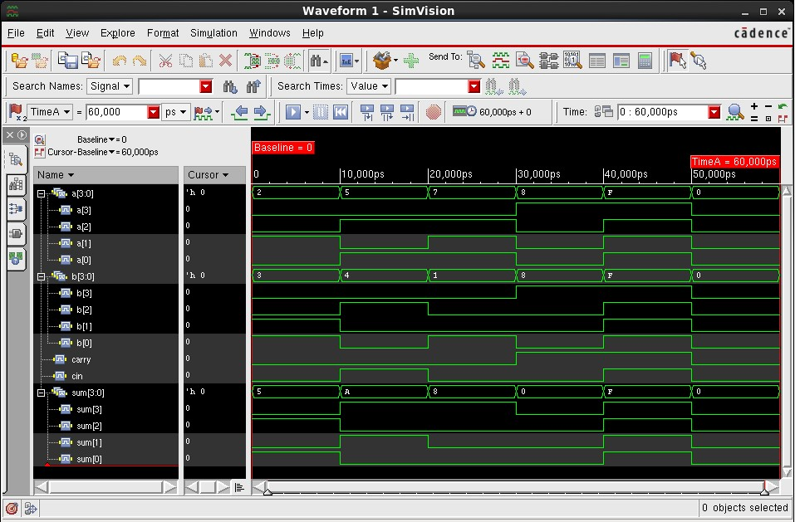 | Figure-1.15. SimVision waveform for fulladder4_test, showing a, b, cin, sum and carry over the full 60 ns simulation, confirming correct 4-bit ripple addition for all applied vectors.

1.4.4 8-bit Full Adder (fulladder8)
The 8-bit full adder extended the same vector-based dataflow style to 8-bit input vectors a[7:0] and b[7:0], with a scalar cin and a carry-out renamed cout: assign {cout, sum} = a + b + cin. The Verilog source code is shown in Figure-1.16.
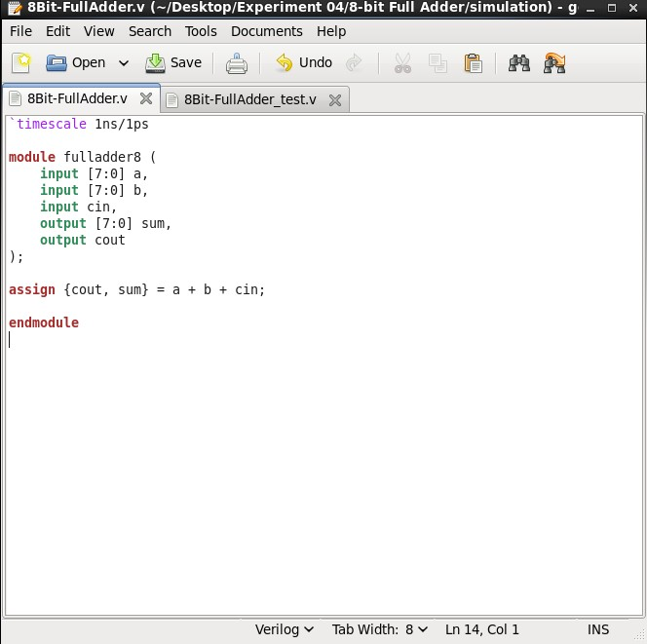 | 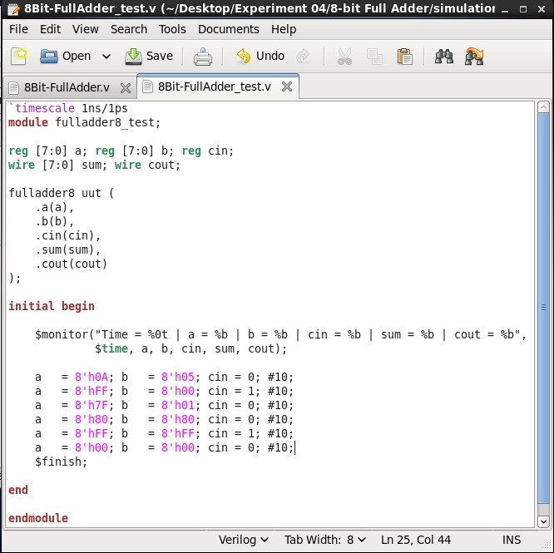
Figure-1.16. Verilog source code (8Bit-FullAdder.v) for the 8-bit full adder: assign {cout, sum} = a + b + cin, with 8-bit inputs a[7:0], b[7:0] and a scalar cin. | Figure-1.17. Verilog test bench source code (8Bit-FullAdder_test.v), instantiating fulladder8 as uut and applying six 10 ns-wide 8-bit hexadecimal stimulus vectors, including a = b = 8’hFF, cin = 1.

The test bench (8Bit-FullAdder_test.v) applied six 8-bit hexadecimal stimulus vectors (10 ns each), including a = b = 8’hFF with cin = 1, exercising the carry-out path. The test bench source code is shown in Figure-1.17.

The design compiled and elaborated without errors, with the worklib populated with the fulladder8 and fulladder8_test modules and a Snapshots entry for worklib.fulladder8_test:module, as shown in Figure-1.18.

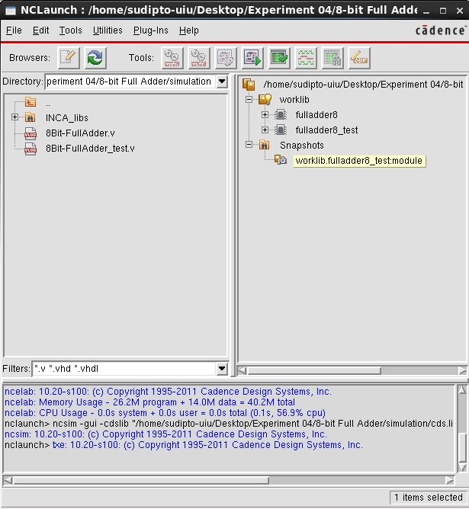 | 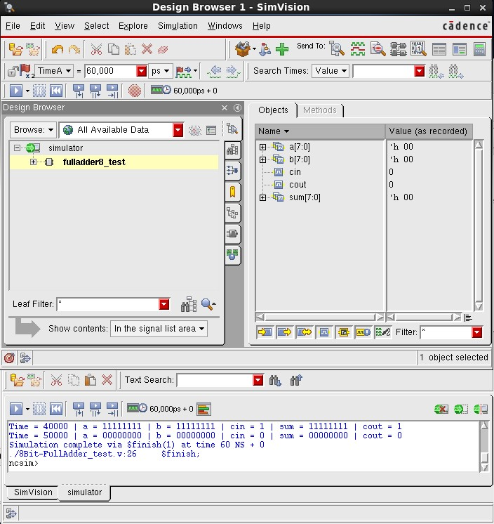
Figure-1.18. NCLaunch window for the 8-bit full adder, showing the worklib with the compiled fulladder8 and fulladder8_test modules and the elaborated Snapshots entry, confirming successful compilation and elaboration. | Figure-1.19. SimVision Design Browser and Console windows for fulladder8_test, showing the recorded signal values and $monitor output confirming that sum and cout correctly equal a + b + cin for each applied vector.
The SimVision Console output confirms correct operation for example, a = 8’hFF, b = 8’hFF and cin = 1 give sum = 8’hFF and cout = 1 (0xFF + 0xFF + 1 = 0x1FF) with the simulation completing via $finish at 60 ns, as shown in Figure-1.19. The corresponding waveform, plotting a, b, cin, sum and cout over the full 60 ns simulation, is shown in Figure-1.20.
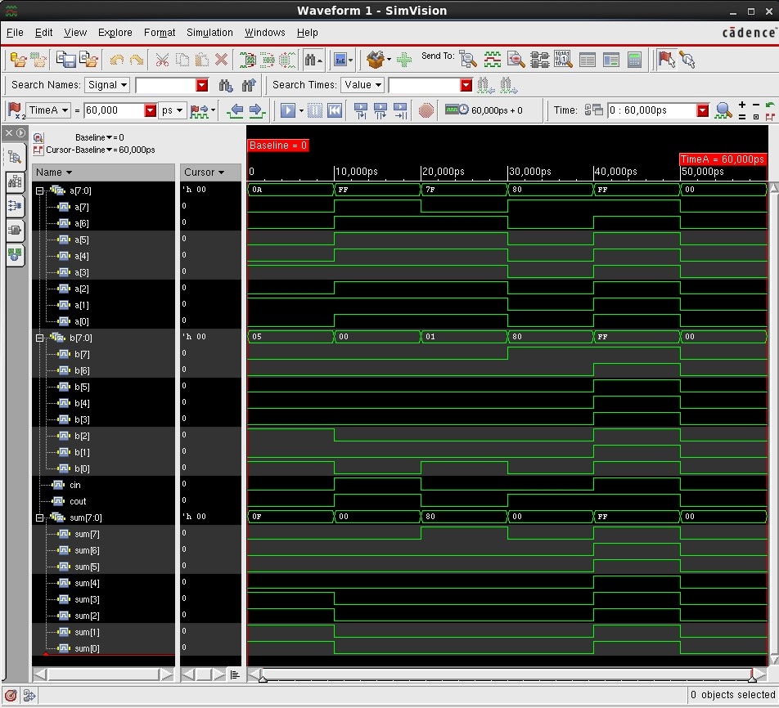 | Figure-1.20. SimVision waveform for fulladder8_test, showing a, b, cin, sum and cout over the full 60 ns simulation, confirming correct 8-bit ripple addition for all applied vectors.

1.4.5 16-bit Full Adder (fulladder16)
The 16-bit full adder used the same pattern with 16-bit input vectors a[15:0] and b[15:0]: assign {cout, sum} = a + b + cin. The Verilog source code is shown in Figure-1.21.

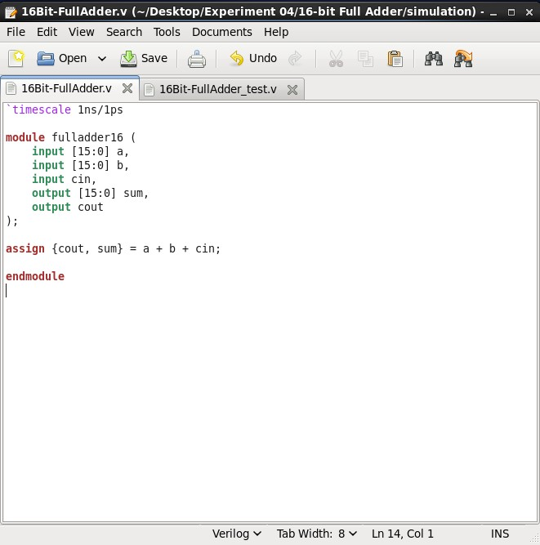 | 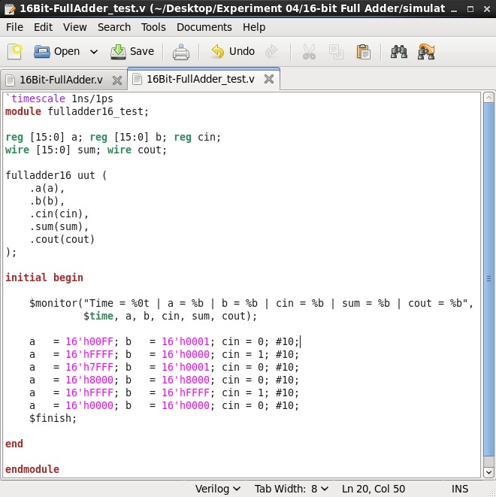
Figure-1.21. Verilog source code (16Bit-FullAdder.v) for the 16-bit full adder: assign {cout, sum} = a + b + cin, with 16-bit inputs a[15:0], b[15:0] and a scalar cin. | Figure-1.22. Verilog test bench source code (16Bit-FullAdder_test.v), instantiating fulladder16 as uut and applying six 10 ns-wide 16-bit hexadecimal stimulus vectors, including a = b = 16’hFFFF, cin = 1.

The test bench (16Bit-FullAdder_test.v) applied six 16-bit hexadecimal stimulus vectors (10 ns each), including a = b = 16’hFFFF with cin = 1. The test bench source code is shown in Figure-1.22.

The design compiled and elaborated without errors, with the worklib populated with the fulladder16 and fulladder16_test modules and a Snapshots entry for worklib.fulladder16_test:module, as shown in Figure-1.23.

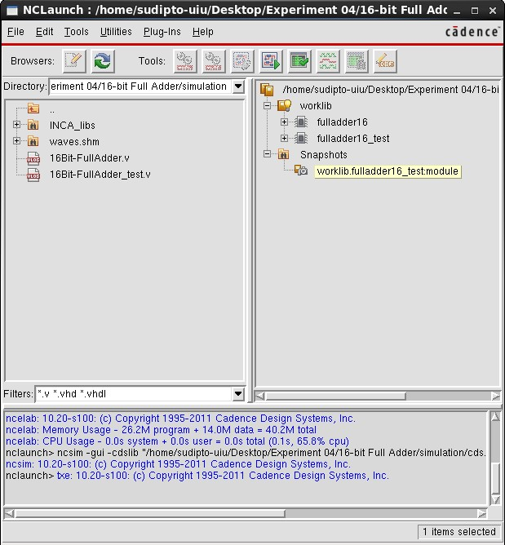 | 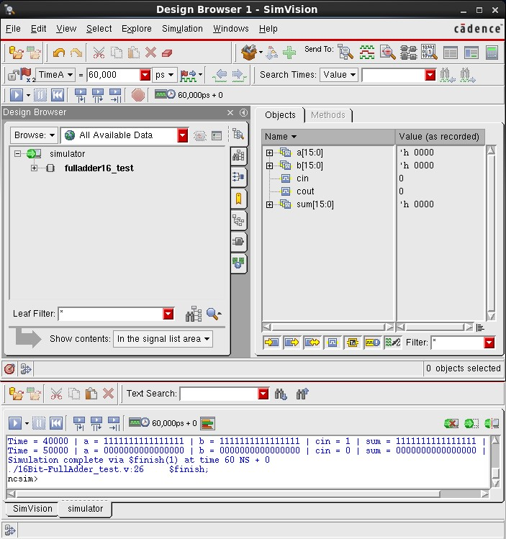
Figure-1.23. NCLaunch window for the 16-bit full adder, showing the worklib with the compiled fulladder16 and fulladder16_test modules and the elaborated Snapshots entry, confirming successful compilation and elaboration. | Figure-1.24. SimVision Design Browser and Console windows for fulladder16_test, showing the recorded signal values and $monitor output confirming that sum and cout correctly equal a + b + cin for each applied vector.

The SimVision Console output confirms correct operation for example, a = 16’hFFFF, b = 16’hFFFF and cin = 1 give sum = 16’hFFFF and cout = 1 with the simulation completing via $finish at 60 ns, as shown in Figure-1.24. Because the 16-bit bus is too wide to read individual bit values directly from a single hexadecimal trace, the waveform was captured in four views: Figure-1.25 shows all signals (a, b, cin, cout and sum) as hexadecimal bus values over the full 60 ns simulation; Figure-1.26, Figure-1.27 and Figure-1.28 show the individual input a, input b, and output sum expanded bit-by-bit (a[15] down to a[0], and so on), confirming the value recorded on every one of the 16 bits at each simulation time.

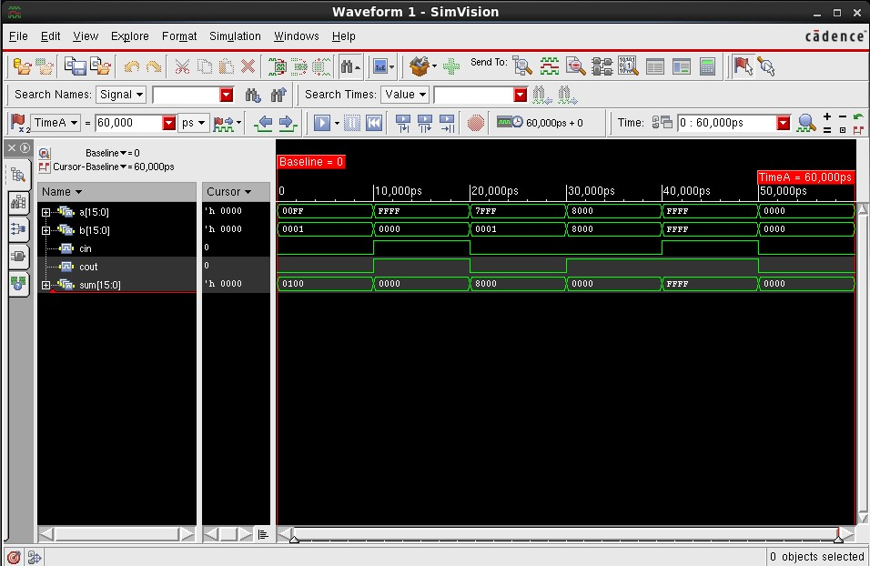
Figure-1.25. SimVision waveform for fulladder16_test, showing a, b, cin, cout and sum as hexadecimal bus values over the full 60 ns simulation.
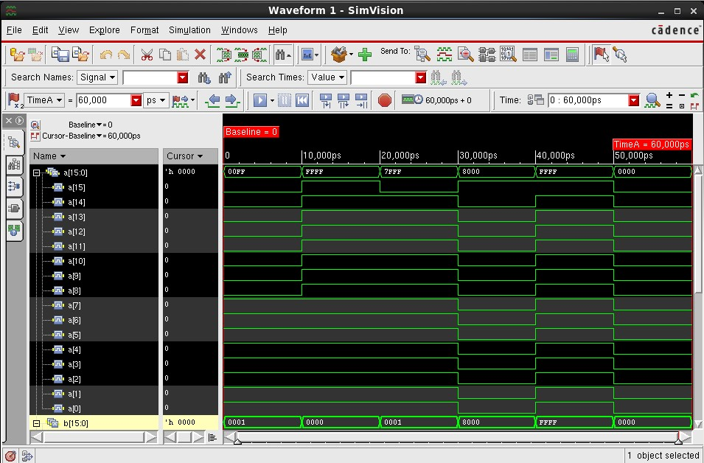
Figure-1.26. SimVision waveform for fulladder16_test with input a[15:0] expanded bit-by-bit, confirming the individual bit pattern of a at each simulation time.

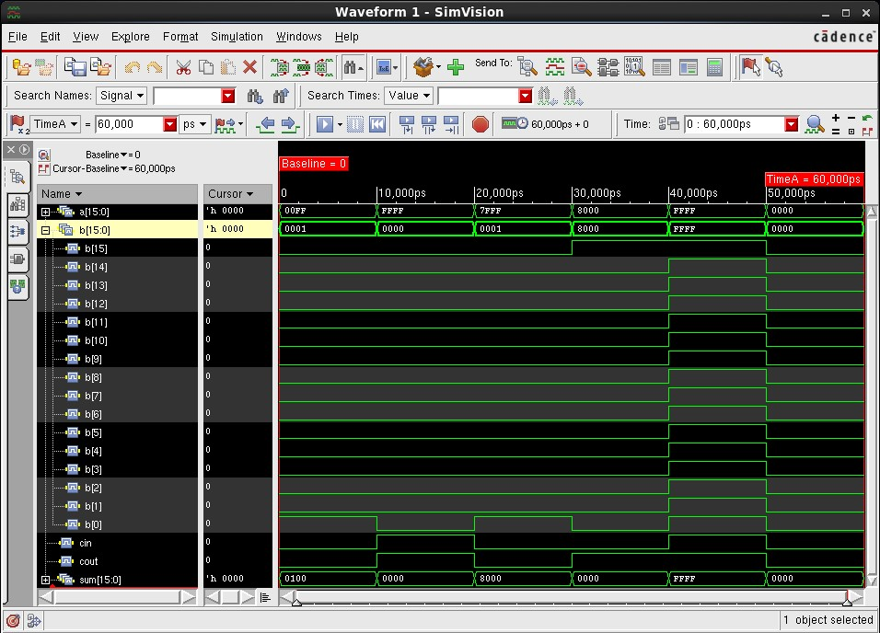
Figure-1.27. SimVision waveform for fulladder16_test with input b[15:0] expanded bit-by-bit, confirming the individual bit pattern of b at each simulation time.
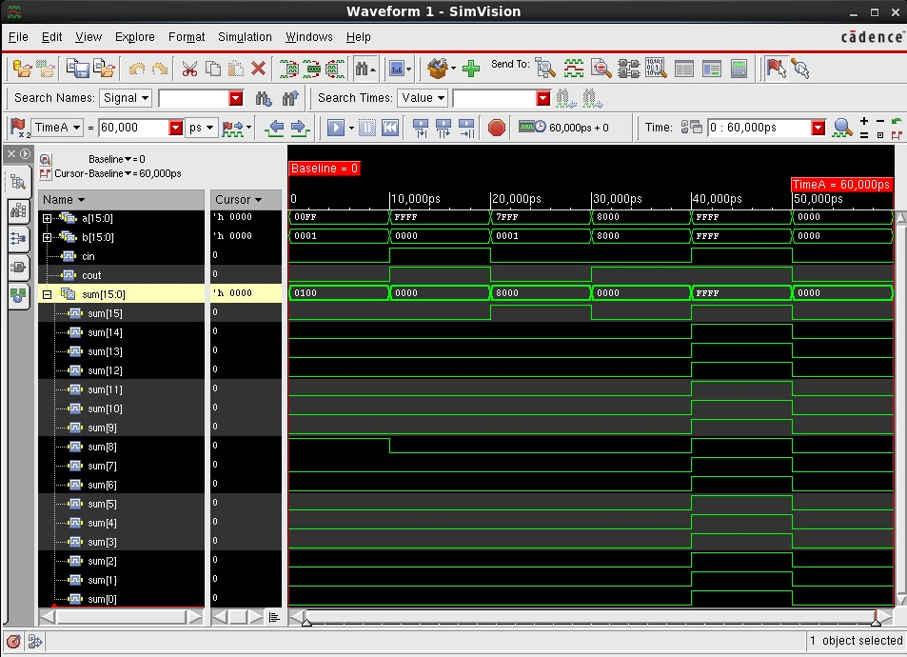
Figure-1.28. SimVision waveform for fulladder16_test with output sum[15:0] expanded bit-by-bit, confirming the individual bit pattern of the computed sum at each simulation time.
1.4.6 32-bit Full Adder (fulladder32)
The 32-bit full adder used the same pattern with 32-bit input vectors a[31:0] and b[31:0]: assign {cout, sum} = a + b + cin. The Verilog source code is shown in Figure-1.29.

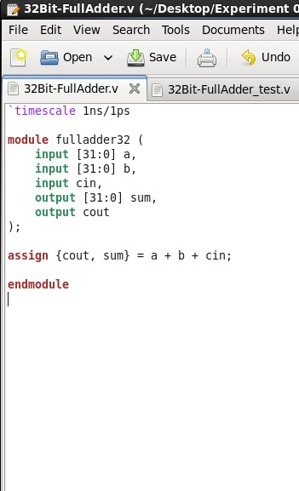 | 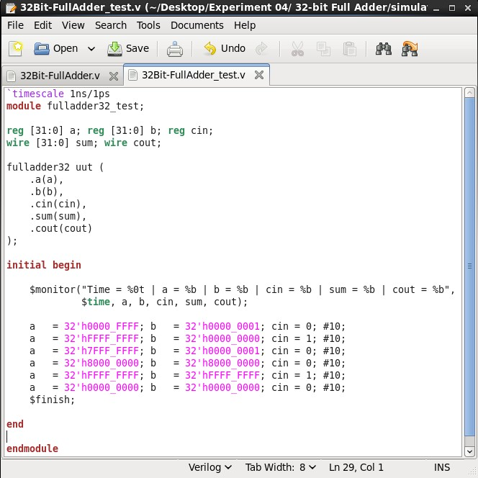
Figure-1.29. Verilog source code (32Bit-FullAdder.v) for the 32-bit full adder: assign {cout, sum} = a + b + cin, with 32-bit inputs a[31:0], b[31:0] and a scalar cin. | Figure-1.30. Verilog test bench source code (32Bit-FullAdder_test.v), instantiating fulladder32 as uut and applying six 10 ns-wide 32-bit hexadecimal stimulus vectors, including a = b = 32’hFFFF_FFFF, cin = 1.

The test bench (32Bit-FullAdder_test.v) applied six 32-bit hexadecimal stimulus vectors (10 ns each), including a = b = 32’hFFFF_FFFF with cin = 1. The test bench source code is shown in Figure-1.30.

The design compiled and elaborated without errors, with the worklib populated with the fulladder32 and fulladder32_test modules and a Snapshots entry for worklib.fulladder32_test:module, as shown in Figure-1.31.

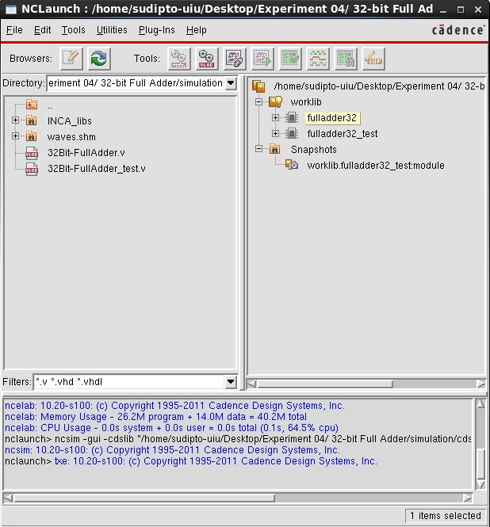 | 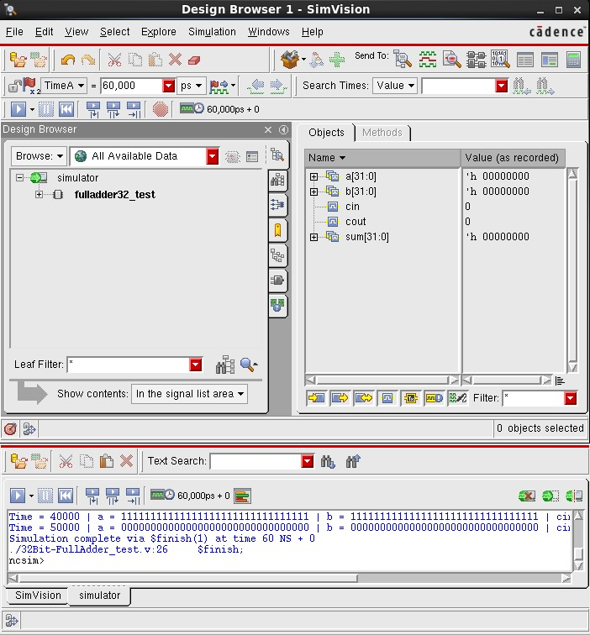
Figure-1.31. NCLaunch window for the 32-bit full adder, showing the worklib with the compiled fulladder32 and fulladder32_test modules and the elaborated Snapshots entry, confirming successful compilation and elaboration. | Figure-1.32. SimVision Design Browser and Console windows for fulladder32_test, showing the recorded signal values and $monitor output confirming that sum and cout correctly equal a + b + cin for each applied vector.
The SimVision Console output confirms correct operation for every applied 32-bit vector, with the simulation completing via $finish at 60 ns, as shown in Figure-1.32. As with the 16-bit design, the waveform was captured in four views: Figure-1.33 shows all signals as hexadecimal bus values over the full simulation; Figure-1.34, Figure-1.35 and Figure-1.36 show the individual input a, input b, and output sum expanded bit-by-bit across all 32 bits.
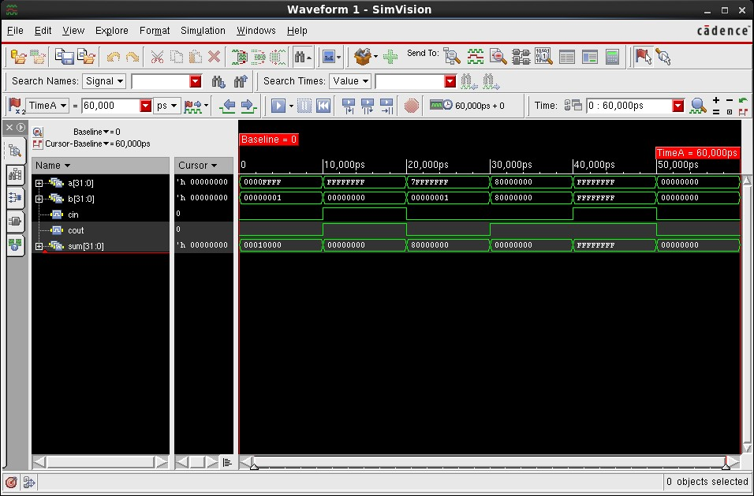
Figure-1.33. SimVision waveform for fulladder32_test, showing a, b, cin, cout and sum as hexadecimal bus values over the full 60 ns simulation.
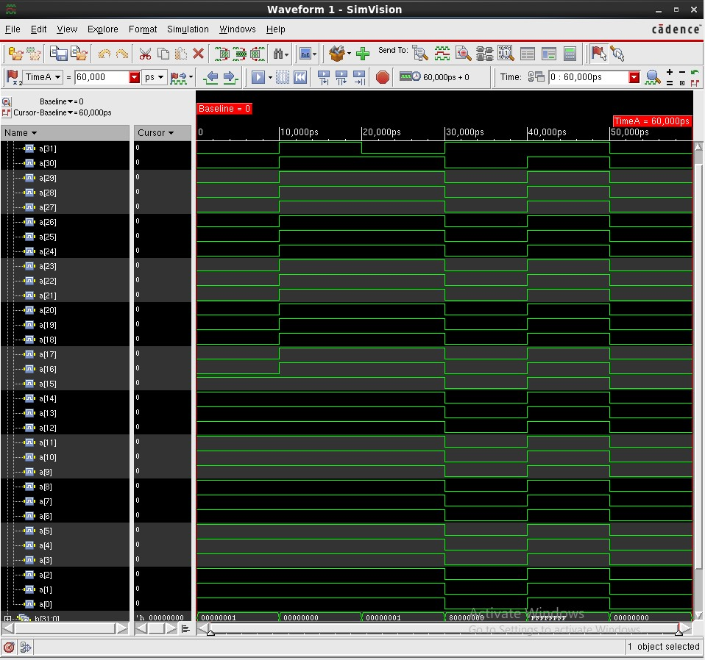
Figure-1.34. SimVision waveform for fulladder32_test with input a[31:0] expanded bit-by-bit, confirming the individual bit pattern of a at each simulation time.
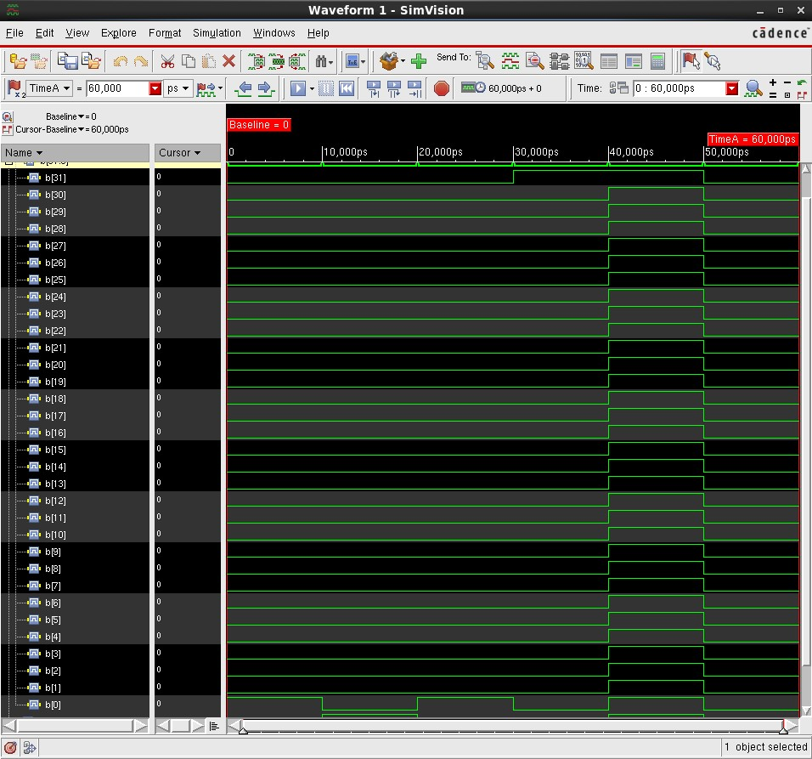
Figure-1.35. SimVision waveform for fulladder32_test with input b[31:0] expanded bit-by-bit, confirming the individual bit pattern of b at each simulation time.
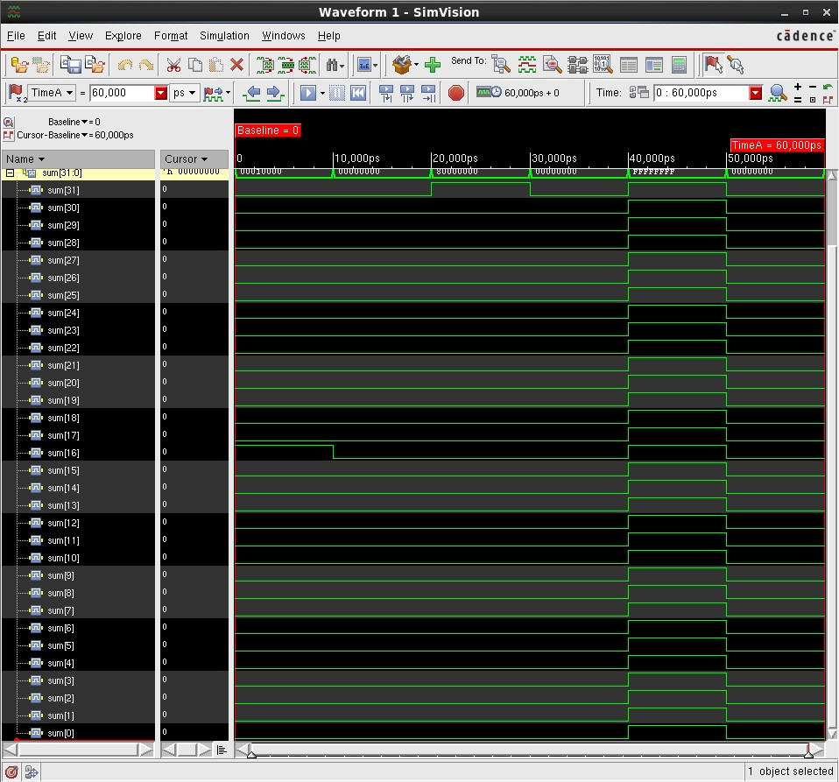
Figure-1.36. SimVision waveform for fulladder32_test with output sum[31:0] expanded bit-by-bit, confirming the individual bit pattern of the computed sum at each simulation time.
1.4.7 64-bit Full Adder (fulladder64)
The 64-bit full adder used the same pattern with 64-bit input vectors a[63:0] and b[63:0]: assign {cout, sum} = a + b + cin. The Verilog source code is shown in Figure-1.37.
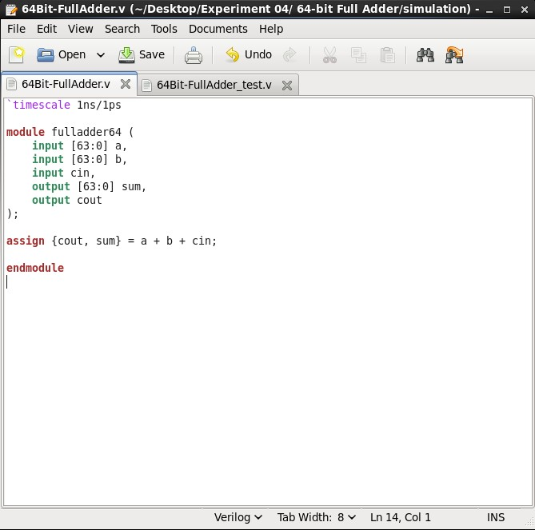 | 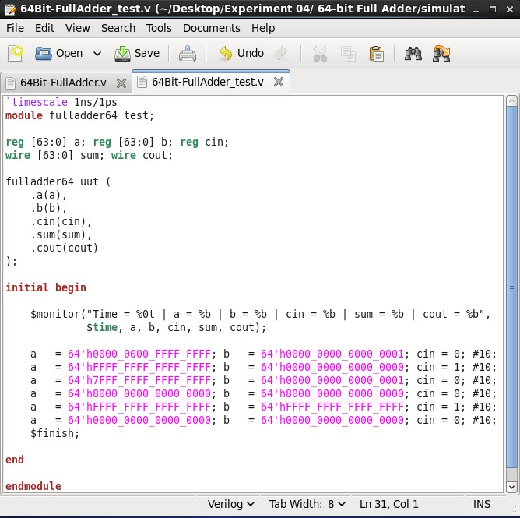
Figure-1.37. Verilog source code (64Bit-FullAdder.v) for the 64-bit full adder: assign {cout, sum} = a + b + cin, with 64-bit inputs a[63:0], b[63:0] and a scalar cin. | Figure-1.38. Verilog test bench source code (64Bit-FullAdder_test.v), instantiating fulladder64 as uut and applying six 10 ns-wide 64-bit hexadecimal stimulus vectors, including a = b = 64’hFFFF_FFFF_FFFF_FFFF, cin = 1.
The test bench (64Bit-FullAdder_test.v) applied six 64-bit hexadecimal stimulus vectors (10 ns each), including a = b = 64’hFFFF_FFFF_FFFF_FFFF with cin = 1. The test bench source code is shown in Figure-1.38.
The design compiled and elaborated without errors, with the worklib populated with the fulladder64 and fulladder64_test modules and a Snapshots entry for worklib.fulladder64_test:module, as shown in Figure-1.39.
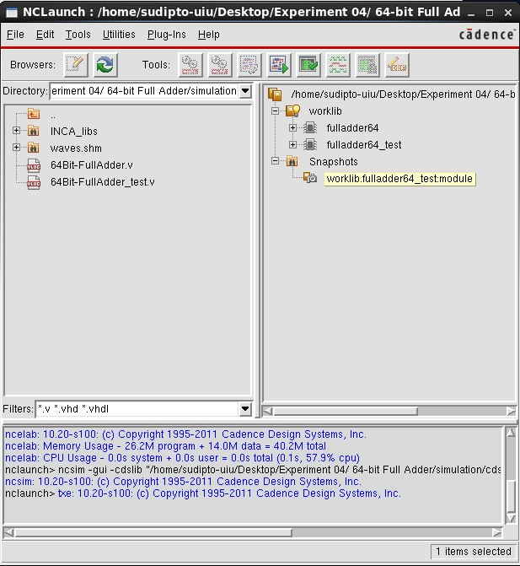 | 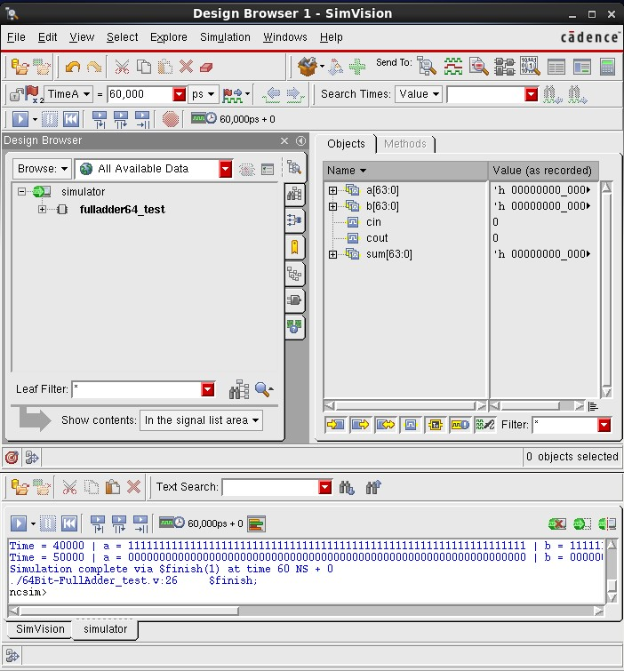
Figure-1.39. NCLaunch window for the 64-bit full adder, showing the worklib with the compiled fulladder64 and fulladder64_test modules and the elaborated Snapshots entry, confirming successful compilation and elaboration | Figure-1.40. SimVision Design Browser and Console windows for fulladder64_test, showing the recorded signal values and $monitor output confirming that sum and cout correctly equal a + b + cin for each applied vector.

The SimVision Console output confirms correct operation for every applied 64-bit vector, with the simulation completing via $finish at 60 ns, as shown in Figure-1.40. Because a 64-bit bus is too wide even for a single bit-expanded view, each 64-bit signal was captured in two half-word screenshots: Figure-1.41 shows all signals as hexadecimal bus values over the full simulation; Figure-1.42 and Figure-1.43 show input a expanded bit-by-bit for bits 63–34 and 33–0 respectively; Figure-1.44 and Figure-1.45 show input b expanded bit-by-bit for bits 63–32 and 31–0; and Figure-1.46 and Figure-1.47 show output sum expanded bit-by-bit for bits 63–32 and 31–0.

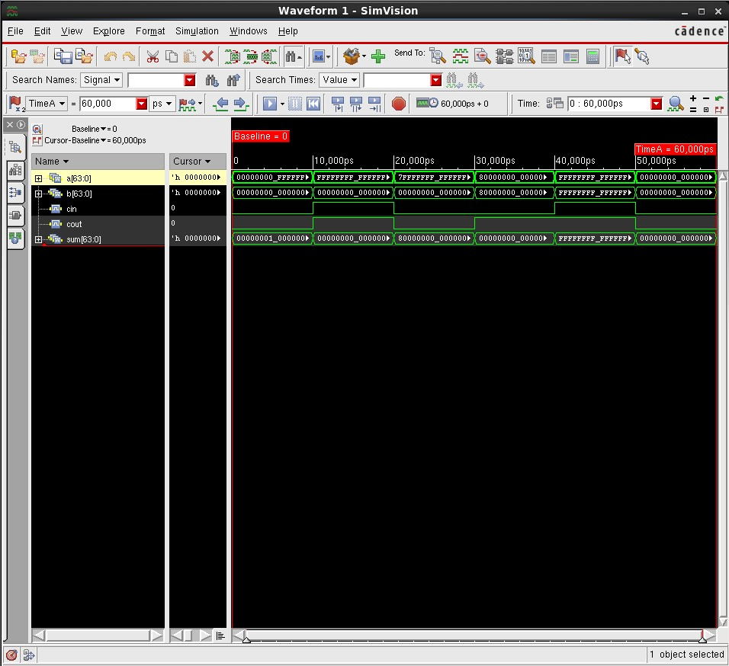
Figure-1.41. SimVision waveform for fulladder64_test, showing a, b, cin, cout and sum as hexadecimal bus values over the full 60 ns simulation.
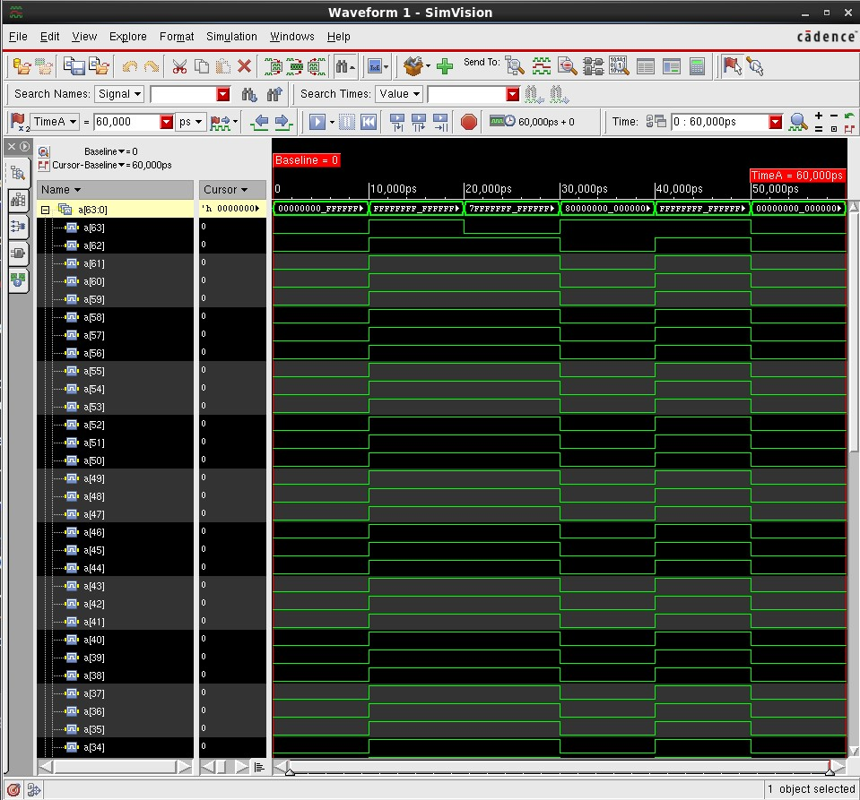
Figure-1.42. SimVision waveform for fulladder64_test with input a[63:34] expanded bit-by-bit.

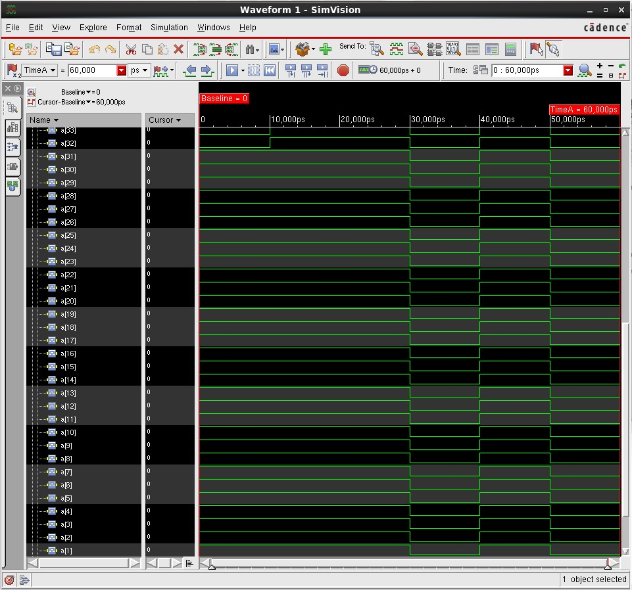
Figure-1.43. SimVision waveform for fulladder64_test with input a[33:0] expanded bit-by-bit.

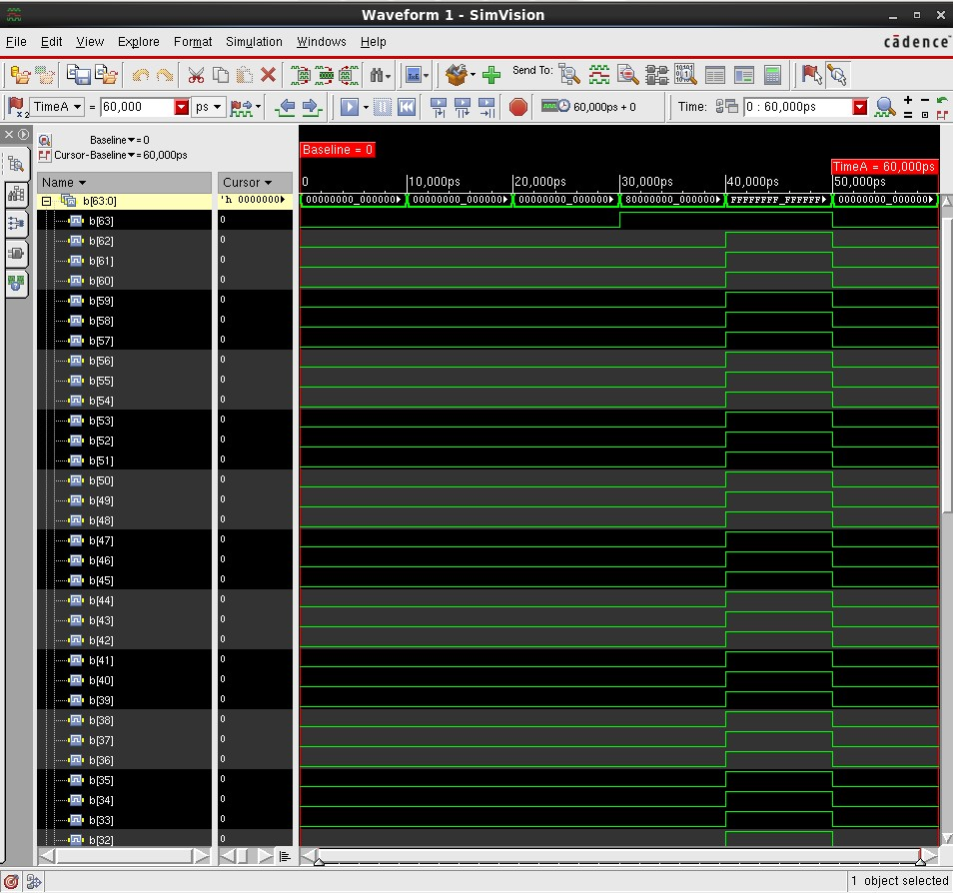
Figure-1.44. SimVision waveform for fulladder64_test with input b[63:32] expanded bit-by-bit.

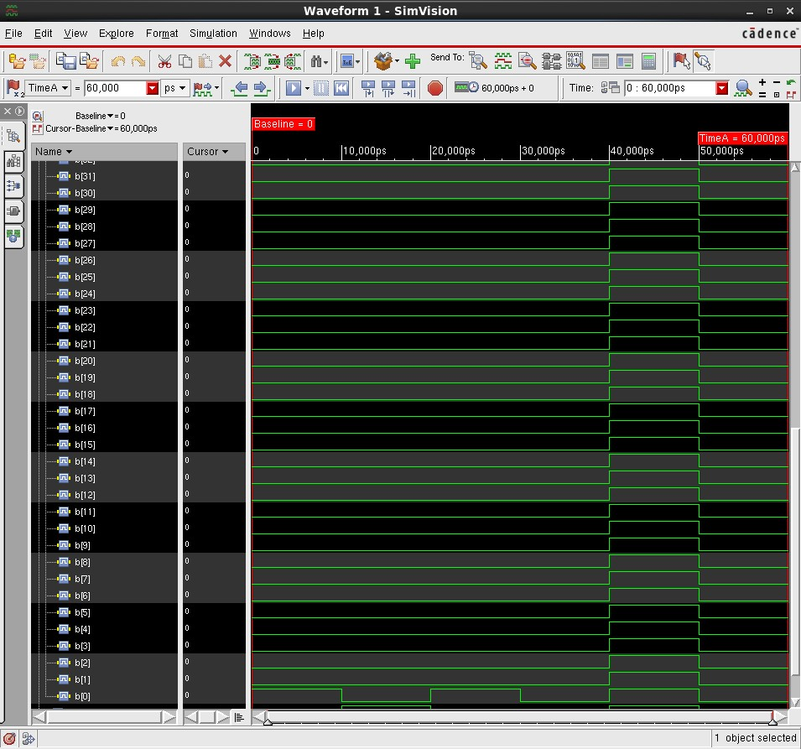
Figure-1.45. SimVision waveform for fulladder64_test with input b[31:0] expanded bit-by-bit.

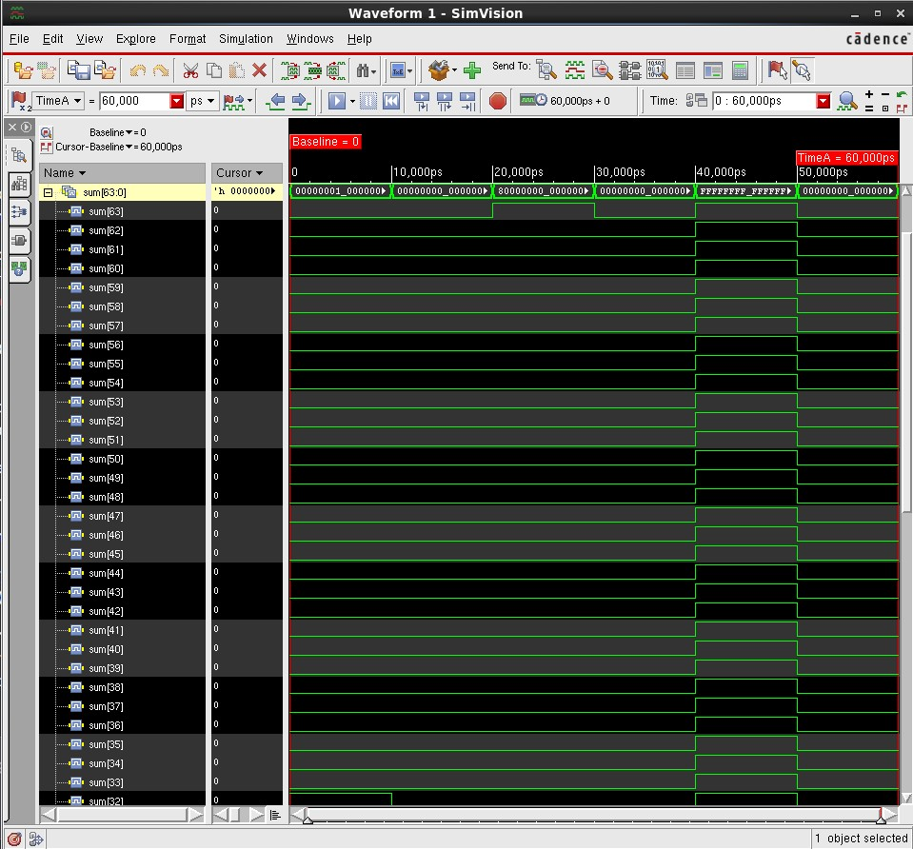
Figure-1.46. SimVision waveform for fulladder64_test with output sum[63:32] expanded bit-by-bit.

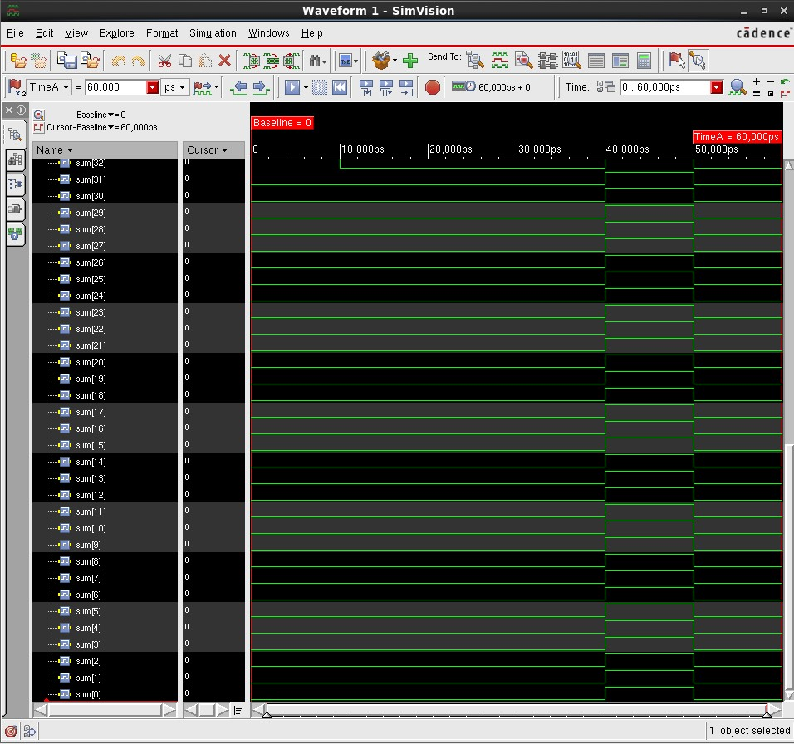
Figure-1.47. SimVision waveform for fulladder64_test with output sum[31:0] expanded bit-by-bit, together confirming the individual bit pattern of the 64-bit computed sum at each simulation time.
1.4.8 4-bit Subtractor (subtractor4)
The 4-bit subtractor was described using the same vector-based dataflow style as the adders, with 4-bit input vectors a[3:0] and b[3:0], a borrow-in bin, and a single statement, assign {bout, diff} = a - b - bin, relying on Verilog’s two’s-complement arithmetic to produce a borrow-out bout whenever the subtraction underflows. The Verilog source code is shown in Figure-1.48.
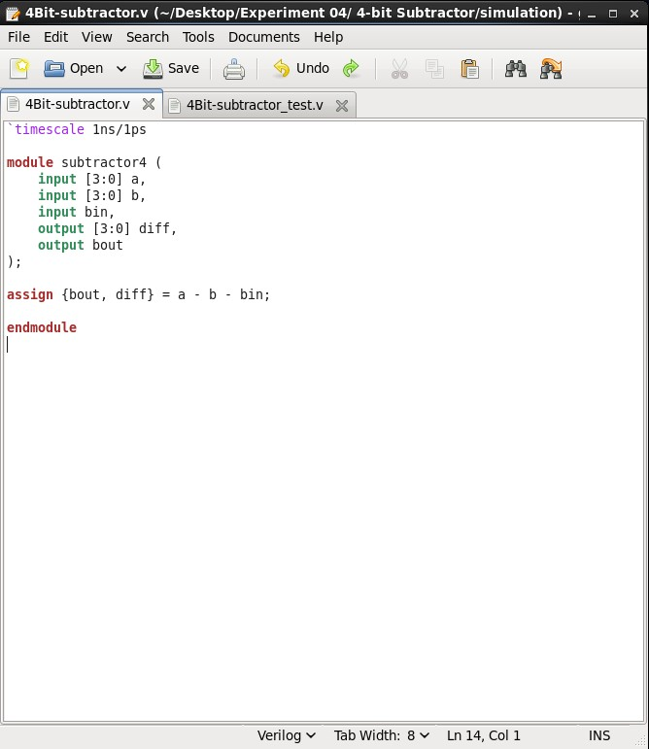 | 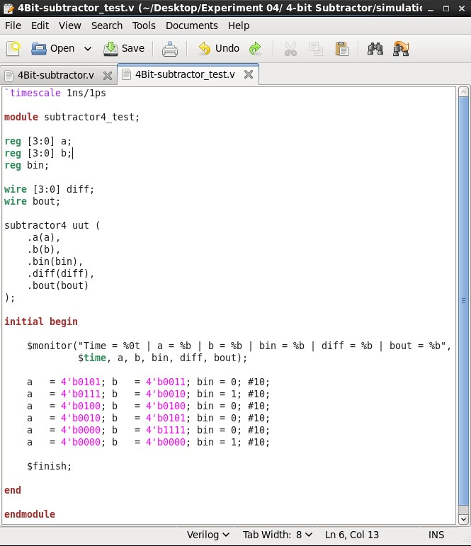
Figure-1.48. Verilog source code (4Bit-subtractor.v) for the 4-bit subtractor: assign {bout, diff} = a - b - bin, with 4-bit inputs a[3:0], b[3:0] and a scalar borrow-in bin. | Figure-1.49. Verilog test bench source code (4Bit-subtractor_test.v), instantiating subtractor4 as uut and applying six 10 ns-wide 4-bit stimulus vectors, including cases that underflow and set the borrow-out.
The test bench (4Bit-subtractor_test.v) applied six 4-bit stimulus vectors (10 ns each), including cases where b (plus bin) exceeds a, exercising the borrow-out path. The test bench source code is shown in Figure-1.49.

The design compiled and elaborated without errors, with the worklib populated with the subtractor4 and subtractor4_test modules and a Snapshots entry for worklib.subtractor4_test:module, as shown in Figure-1.50.

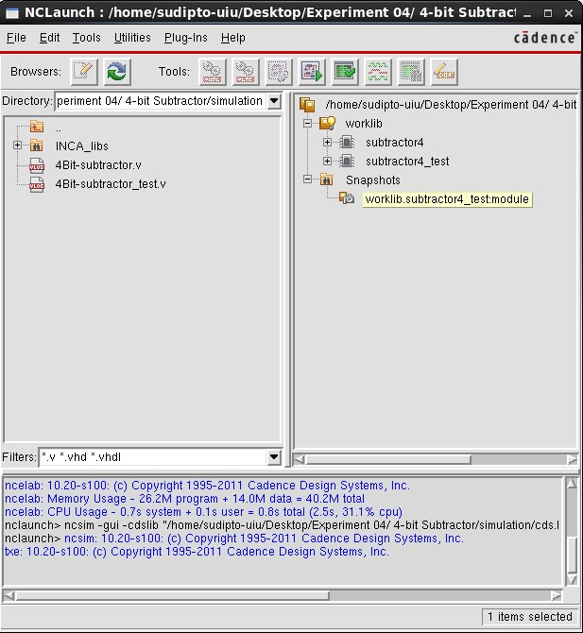 | 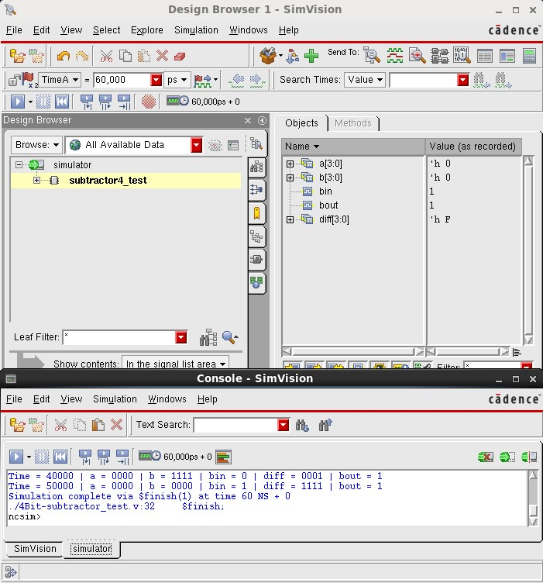
Figure-1.50. NCLaunch window for the 4-bit subtractor, showing the worklib with the compiled subtractor4 and subtractor4_test modules and the elaborated Snapshots entry, confirming successful compilation and elaboration. | Figure-1.51. SimVision Design Browser and Console windows for subtractor4_test, showing the recorded signal values and $monitor output confirming that diff and bout correctly equal a − b − bin (in two’s complement) for each applied vector.

The SimVision Console output confirms correct two’s-complement subtraction for example, a = 4’b0000, b = 4’b1111 and bin = 0 give diff = 4’b0001 and bout = 1 (0 − 15 wraps to 1 modulo 16, with a borrow), and a = 4’b0000, b = 4’b0000 and bin = 1 give diff = 4’b1111 and bout = 1 with the simulation completing via $finish at 60 ns, as shown in Figure-1.51. The corresponding waveform, plotting a, b, bin, diff and bout over the full 60 ns simulation, is shown in Figure-1.52.

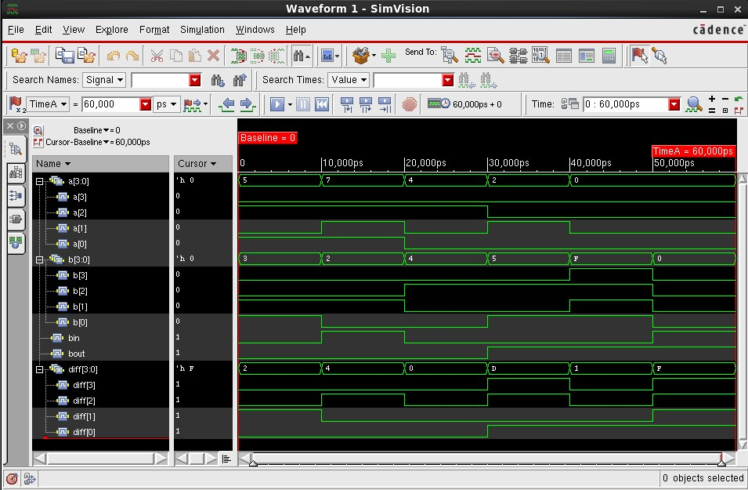
Figure-1.52. SimVision waveform for subtractor4_test, showing a, b, bin, diff and bout over the full 60 ns simulation, confirming correct 4-bit subtraction, including borrow-out, for all applied vectors.
1.4.9 4-bit Multiplier (multiplier4)
The 4-bit multiplier was described using a single dataflow statement, assign prod = a * b, with two 4-bit input vectors a[3:0] and b[3:0] and an 8-bit output vector prod[7:0] wide enough to hold the full product of two 4-bit numbers without overflow. The Verilog source code is shown in Figure-1.53.
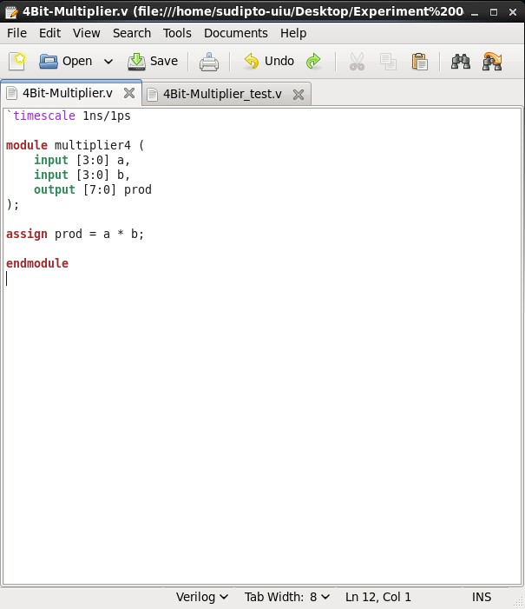 | 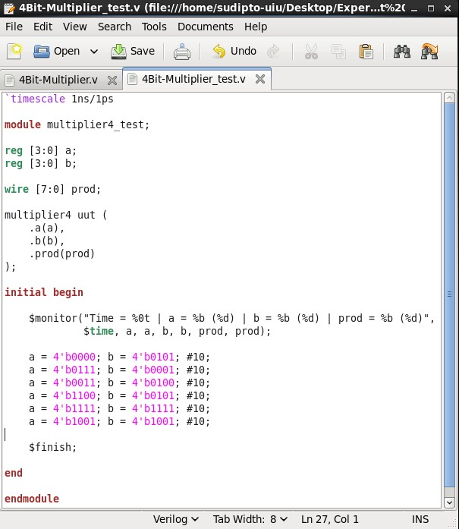
Figure-1.53. Verilog source code (4Bit-Multiplier.v) for the 4-bit multiplier: assign prod = a * b, with 4-bit inputs a[3:0], b[3:0] and an 8-bit output prod[7:0]. | Figure-1.54. Verilog test bench source code (4Bit-Multiplier_test.v), instantiating multiplier4 as uut and applying six 10 ns-wide 4-bit stimulus vectors, with $monitor printing a, b and prod in both binary and decimal.

The test bench (4Bit-Multiplier_test.v) applied six 4-bit stimulus vectors (10 ns each), with a $monitor statement printing each of a, b and prod in both binary and decimal form. The test bench source code is shown in Figure-1.54.

The design compiled and elaborated without errors, with the worklib populated with the multiplier4 and multiplier4_test modules and a Snapshots entry for worklib.multiplier4_test:module, as shown in Figure-1.55.

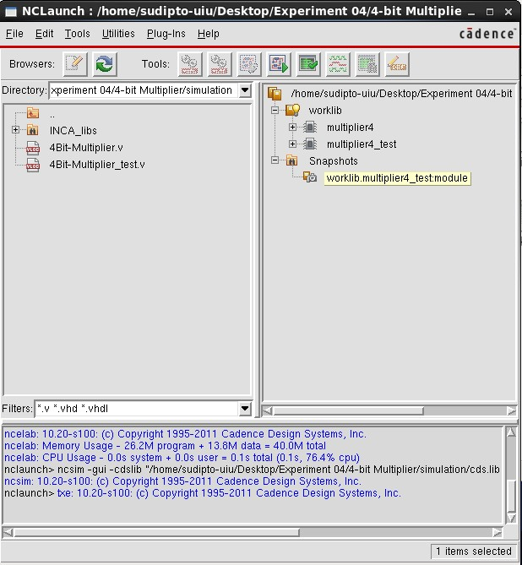 | 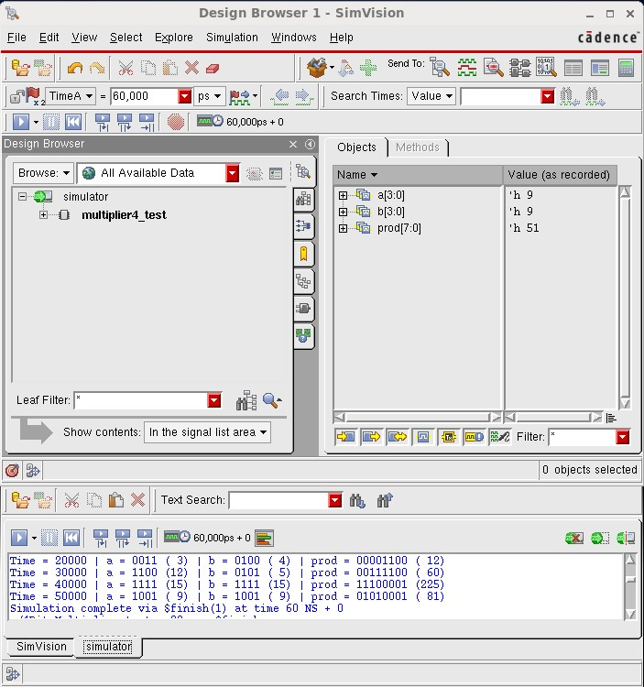
Figure-1.55. NCLaunch window for the 4-bit multiplier, showing the worklib with the compiled multiplier4 and multiplier4_test modules and the elaborated Snapshots entry, confirming successful compilation and elaboration. | Figure-1.56. SimVision Design Browser and Console windows for multiplier4_test, showing the recorded signal values and $monitor output confirming that prod correctly equals a × b for each applied vector, in both binary and decimal.

The SimVision Console output confirms correct multiplication for example, a = 4’b1001 (9) and b = 4’b1001 (9) give prod = 8’b01010001 (81 = 9 × 9), and a = 4’b1111 (15) and b = 4’b1111 (15) give prod = 8’b11100001 (225 = 15 × 15) with the simulation completing via $finish at 60 ns, as shown in Figure-1.56. The corresponding waveform, plotting a, b and prod over the full 60 ns simulation, is shown in Figure-1.57.

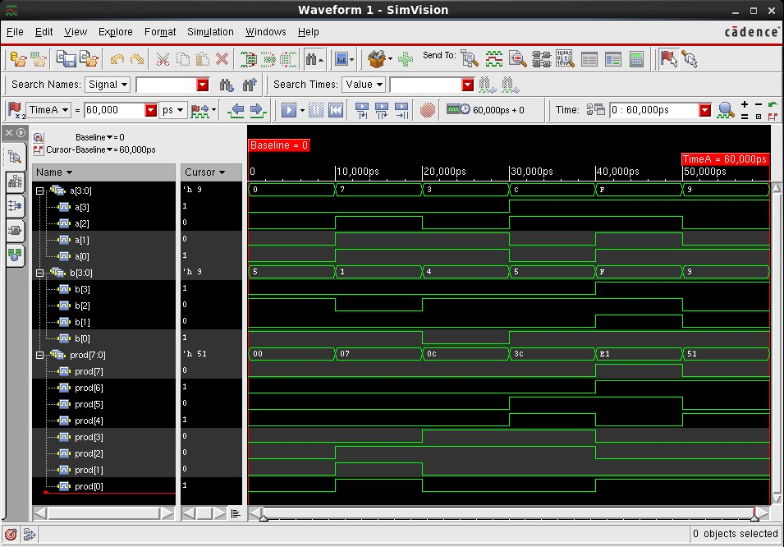
Figure-1.57. SimVision waveform for multiplier4_test, showing a, b and prod over the full 60 ns simulation, confirming correct 4-bit multiplication for all applied vectors.
1.5 Discussion
The lab manual describes building the 4-bit full adder hierarchically: composing a 1-bit full adder from two half-adder instances and an OR gate, then instantiating four copies inside a generate block, with an internal carry_chain vector connecting the carry-out of each stage to the carry-in of the next. In this implementation, however, both the 1-bit full adder and every wider adder were instead described as single dataflow statements sum = a ^ b ^ cin and carry = (a & b) | (b & cin) | (cin & a) for the 1-bit case, and {carry, sum} = a + b + cin for the 4-bit, 8-bit, 16-bit, 32-bit and 64-bit adders rather than by explicit generate-block instantiation of smaller full-adder cells. Carry propagation between bit positions is therefore handled implicitly by the simulator’s evaluation of the + operator on the concatenated {carry, sum} result, rather than by a carry_chain wire threaded through instantiated stages; functionally this still models the same ripple-carry behaviour a generate-block composition would produce, since every wider sum was verified to equal the arithmetic sum of its operands and incoming carry for each applied test vector.
1.6 Conclusion
In this experiment, a half adder, a 1-bit full adder, ripple-carry full adders of width 4, 8, 16, 32 and 64 bits, a 4-bit subtractor, and a 4-bit multiplier were each designed in Verilog HDL and verified using the Cadence Incisive Enterprise Simulator (IES) through the NCLaunch design flow. The half adder and 1-bit full adder were implemented as direct dataflow expressions of their Boolean truth tables, while every wider adder, the subtractor, and the multiplier were implemented as vector-based dataflow descriptions using Verilog’s built-in arithmetic operators. Each design was compiled with ncvlog, elaborated with ncelab, and simulated, and the resulting SimVision waveforms and $monitor console output confirmed correct behaviour correct sums and carries for every adder width, correct borrow-subtraction, and correct multiplication for every applied test vector. This experiment provided practical, hands-on experience with dataflow arithmetic modeling in Verilog at rapidly increasing scale, and with reading multi-bit SimVision waveforms that must be split across several bus-level and bit-expanded views once the design width exceeds what a single screenshot can show clearly.

